**Algorithm and programming**

**Defining Instruction**



**Dafa Cahya Alfianiko**

**L200194051**

**INFORMATICS**

**Faculty of Communication and Informatics**

**Muhammadiyah University of Surakarta**

**2019**

Practical work report 3

Assistant name : Ganno Tribuana Kurniaji

Practicum date : 16-9-2019

Activity 1

This is a program that I made (no more 20 lines):

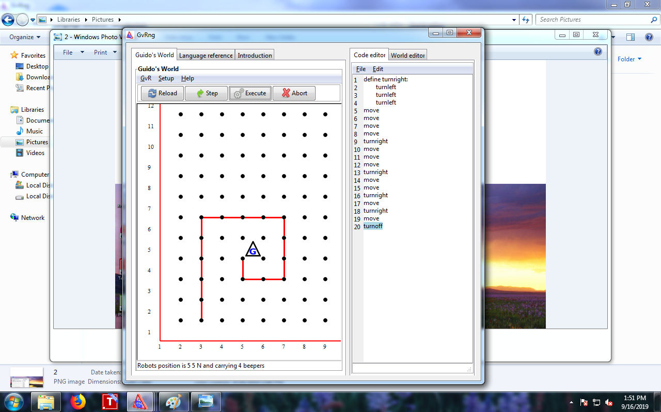

Activity 2

This is a program that I made (no more 19 lines):

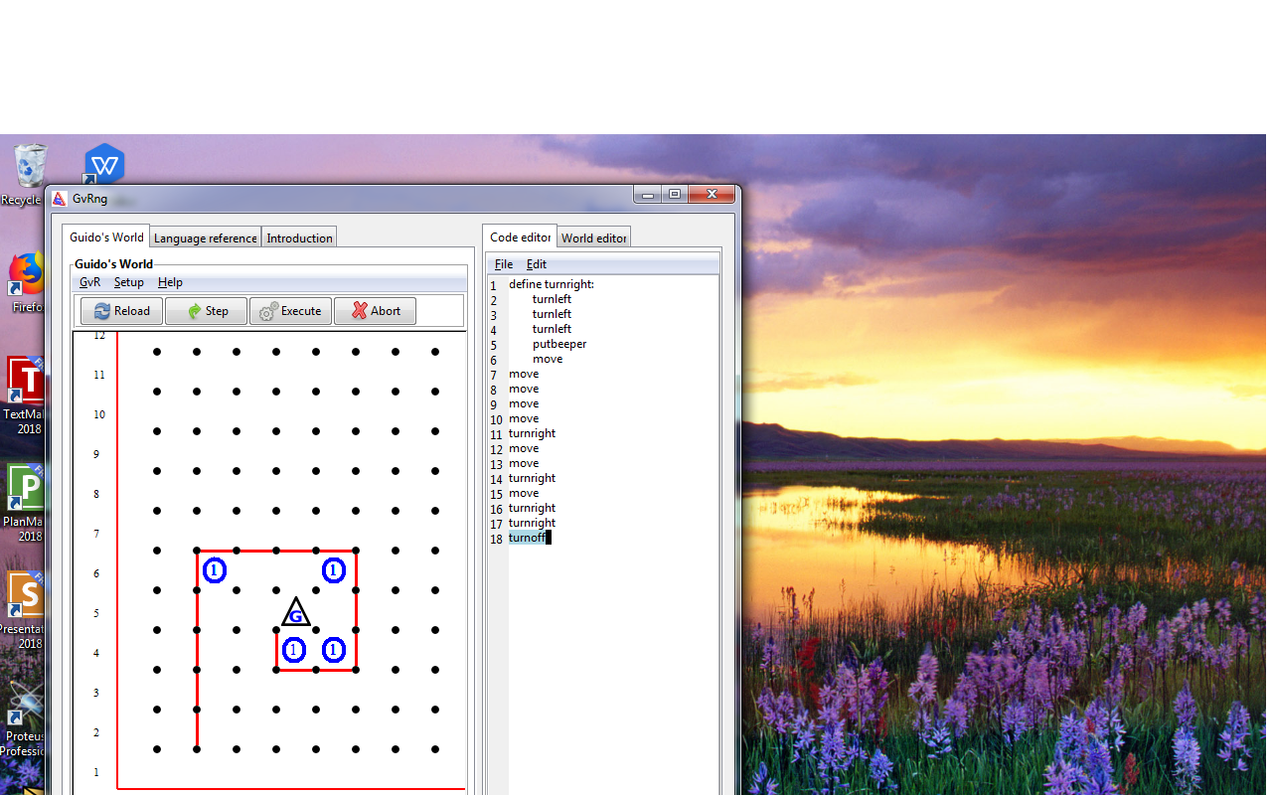

Activity 3

The number of beeper in my program : 40

Number of instructions in the program according to tamplate : 63

This is a screen shot the wondow GvRng after programmed :

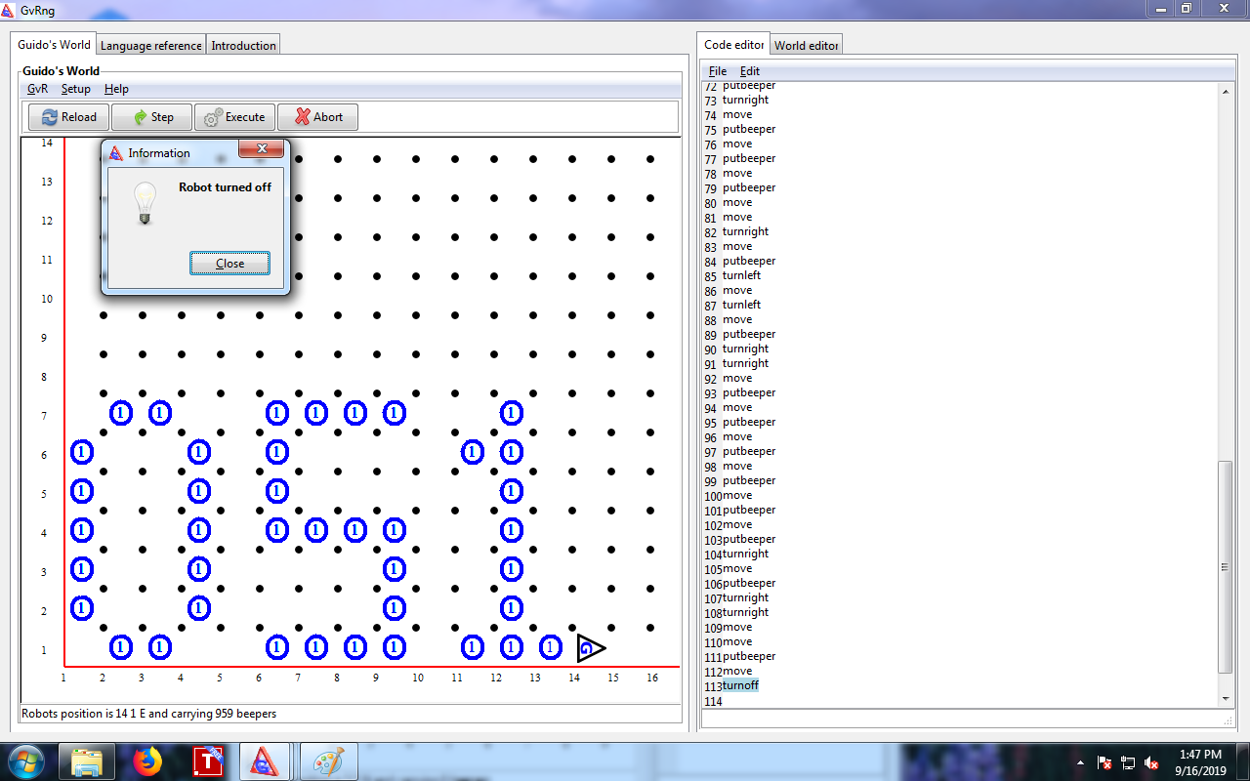

Activity 4

Number of instructions after using the funtion *hadapkanan(turnright)* and *gerakletak(go)* : 100

This is a screen shot of the window GvRng after programmed :

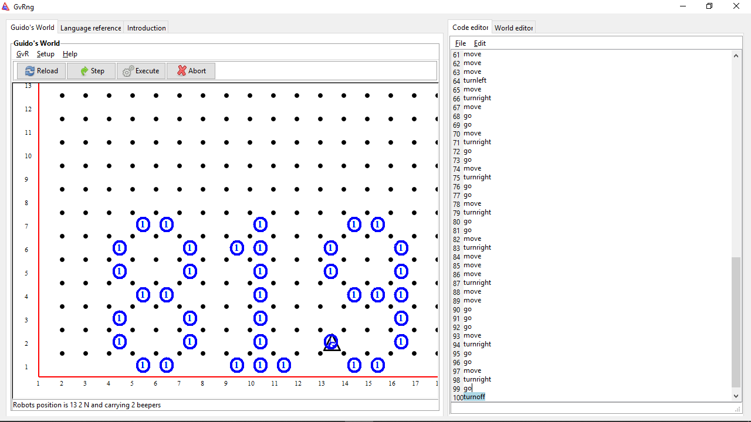

Activity 5

Number of instructions lines in my program : 18

This is a program that I made (max. 20 lines) :

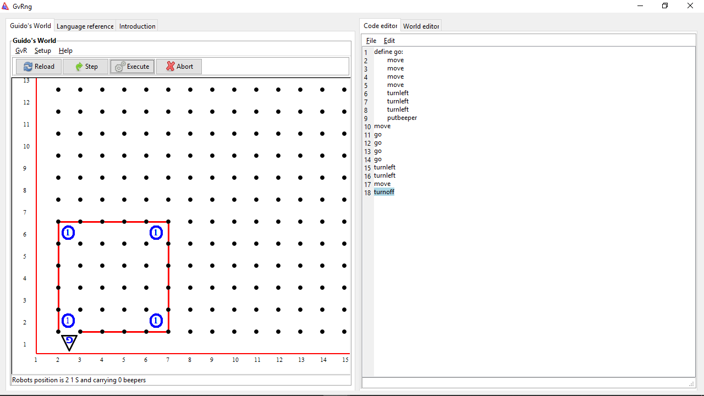

Activity 6

Number of instructions lines in my program : 39

This is a program that I made :

